**Tanaya Mukund Bhide**

**2020BTECS00011**

**BATCH T5**

**SOFTWARE ENGINNERING TOOLS LAB**

**ASSIGNMENT NO 2**

**(Module 2- Software Development Frameworks)**

**1. List of Frameworks/IDEs/Softwares**

**a. Eclipse**

**b. Android SDK**

**c. Node.Js**

**d. DotNet**

**e. Ruby on Rails**

**f. Anaconda**

**g. Google colab**

**h. Django**

**i. Vue.js**

**j. GitHub**

**k. React**

**For every Frameworks/IDEs/Softwares given above provide the answers for below questions**

**1. Original author**

**2. Developers**

**3. Initial release**

**4. Stable release**

**5. Preview release**

**6. Repository (with cloud support )**

**7. Written in (Languages)**

**8. Operating System support**

**9. Platform ,portability**

**10. Available in (Total languages)**

**11. List of languages supported**

**12. Type (Programming tool, integrated development environment etc.)**

**13. Website**

**14. Features**

**15. Size (in MB, GB etc.)**

**16. Privacy and Security**

**17. Type of software (Open source/License)**

**18. If License- Provide details.**

**19. Latest version**

**20. Cloud support (Yes/No)**

**21. Applicability**

**22. Drawbacks (if any)**

a. Eclipse

Original author: IBM

Developers: Eclipse Foundation

Initial release: November 7, 2001

Stable release: 2021-09 (4.21.0)

Preview release: None

Repository (with cloud support): GitHub (https://github.com/eclipse)

Written in (Languages): Java, C++, and others

Operating System support: Windows, macOS, Linux

Platform, portability: Java-based, highly portable

Available in (Total languages): 46

List of languages supported: C, C++, Java, Python, Ruby, PHP, JavaScript, and more

Type (Programming tool, integrated development environment etc.): Integrated development environment (IDE)

Website: https://www.eclipse.org/

Features: Code editing, debugging, testing, version control, plugins and extensions, and more

Size (in MB, GB etc.): Eclipse IDE for Java Developers is around 580 MB

Privacy and Security: Eclipse has a privacy policy and security measures in place to protect users' data

Type of software (Open source/License): Open-source

If License- Provide details: Eclipse Public License (EPL-2.0)

Latest version: 4.21.0

Cloud support (Yes/No): Yes, via plugins and extensions

Applicability: Suitable for developing various types of applications, including web, mobile, desktop, and more

Drawbacks (if any): Can be slow and resource-intensive at times

b. Android SDK

Original author: Android, Inc.

Developers: Google

Initial release: September 23, 2008

Stable release: 31.1.0

Preview release: 32.0.0-beta3

Repository (with cloud support): GitHub (https://github.com/android)

Written in (Languages): Java, Kotlin, and others

Operating System support: Windows, macOS, Linux

Platform, portability: Android platform, highly portable

Available in (Total languages): N/A

List of languages supported: Java, Kotlin, C++, and more

Type (Programming tool, integrated development environment etc.): Software development kit (SDK)

Website: https://developer.android.com/

Features: Tools and APIs for developing Android applications, including libraries, IDE plugins, emulators, and more

Size (in MB, GB etc.): The SDK Manager is around 150 MB

Privacy and Security: Android has a privacy policy and security measures in place to protect users' data

Type of software (Open source/License): Open-source

If License- Provide details: Apache License 2.0

Latest version: 31.1.0

Cloud support (Yes/No): No

Applicability: Suitable for developing Android applications

Drawbacks (if any): Steep learning curve for beginners

c. Node.js

Original author: Ryan Dahl

Developers: Node.js community

Initial release: May 27, 2009

Stable release: 16.13.2

Preview release: None

Repository (with cloud support): GitHub (https://github.com/nodejs/node)

Written in (Languages): JavaScript, C++, and others

Operating System support: Windows, macOS, Linux, FreeBSD, and more

Platform, portability: Cross-platform, highly portable

Available in (Total languages): N/A

List of languages supported: JavaScript, TypeScript, and more

Type (Programming tool, integrated development environment etc.): JavaScript runtime environment

Website: https://nodejs.org/

Features: Asynchronous I/O, event-driven architecture, package ecosystem, cross-platform development, and more

Size (in MB, GB etc.): Node.js installer is around 30 MB

Privacy and Security: Node.js has a privacy policy and security measures in place to protect users' data

Type of software (Open source/License): Open-source

If License- Provide details: Node.js is licensed under the MIT License

Latest version: 16.13.2

Cloud support (Yes/No): Yes, via cloud hosting services such as AWS, Google Cloud Platform, and more

Applicability: Suitable for developing scalable network applications, server-side applications, and more

Drawbacks (if any): Lack of strong typing and complex debugging process

d. DotNet

Original author: Microsoft

Developers: Microsoft

Initial release: February 13, 2002

Stable release: .NET 6.0

Preview release: .NET 7.0 preview 6

Repository (with cloud support): GitHub (https://github.com/dotnet)

Written in (Languages): C#, C++, and others

Operating System support: Windows, macOS, Linux

Platform, portability: Cross-platform, highly portable

Available in (Total languages): N/A

List of languages supported: C#, F#, Visual Basic .NET, and more

Type (Programming tool, integrated development environment etc.): Software framework and development platform

Website: https://dotnet.microsoft.com/

Features: Cross-platform development, runtime, libraries, tools, and more

Size (in MB, GB etc.): The .NET 6.0 SDK installer is around 160 MB

Privacy and Security: .NET has a privacy policy and security measures in place to protect users' data

Type of software (Open source/License): Open-source

If License- Provide details: .NET is licensed under the MIT License

Latest version: .NET 6.0

Cloud support (Yes/No): Yes, via cloud hosting services such as Azure, AWS, Google Cloud Platform, and more

Applicability: Suitable for developing various types of applications, including web, mobile, desktop, and more

Drawbacks (if any): Steep learning curve for beginners, requires substantial system resources

e. Ruby on Rails

Original author: David Heinemeier Hansson

Developers: Ruby on Rails core team

Initial release: December 13, 2005

Stable release: 6.1.3.1

Preview release: 7.0.0.alpha2

Repository (with cloud support): GitHub (https://github.com/rails/rails)

Written in (Languages): Ruby

Operating System support: Windows, macOS, Linux

Platform, portability: Ruby on Rails platform, highly portable

Available in (Total languages): N/A

List of languages supported: Ruby

Type (Programming tool, integrated development environment etc.): Web framework

Website: https://rubyonrails.org/

Features: Model-View-Controller (MVC) architecture, Convention over Configuration (CoC), Don't Repeat Yourself (DRY) principle, and more

Size (in MB, GB etc.): N/A

Privacy and Security: Ruby on Rails has a security policy and various security features in place to protect users' data

Type of software (Open source/License): Open-source

If License- Provide details: MIT License

Latest version: 6.1.3.1

Cloud support (Yes/No): Yes, via cloud hosting providers

Applicability: Suitable for developing web applications and APIs

Drawbacks (if any): Can be slower compared to other web frameworks due to its dynamic nature

f. Anaconda

Original author: Continuum Analytics

Developers: Anaconda, Inc.

Initial release: November 12, 2012

Stable release: 2021.11

Preview release: None

Repository (with cloud support): GitHub (https://github.com/ContinuumIO/anaconda-issues)

Written in (Languages): Python

Operating System support: Windows, macOS, Linux

Platform, portability: Python platform, highly portable

Available in (Total languages): N/A

List of languages supported: Python and R

Type (Programming tool, integrated development environment etc.): Data science platform

Website: https://www.anaconda.com/

Features: Package management, environment management, data visualization, machine learning, and more

Size (in MB, GB etc.): Anaconda installation package is around 500 MB

Privacy and Security: Anaconda has a privacy policy and various security measures in place to protect users' data

Type of software (Open source/License): Open-source and commercial licenses

If License- Provide details: Anaconda Distribution and some packages are under the BSD License, while some packages are under different open-source licenses, and some packages are commercial with free trial

Latest version: 2021.11

Cloud support (Yes/No): Yes, via cloud hosting providers

Applicability: Suitable for data science, machine learning, and scientific computing projects

Drawbacks (if any): Installation and setup process can be challenging for beginners

g. Google Colab

Original author: Google

Developers: Google

Initial release: October 22, 2018

Stable release: Continuous updates

Preview release: None

Repository (with cloud support): Not available

Written in (Languages): Python

Operating System support: Web-based (accessible through web browsers)

Platform, portability: Web-based platform, highly portable

Available in (Total languages): N/A

List of languages supported: Python

Type (Programming tool, integrated development environment etc.): Cloud-based Jupyter notebook environment

Website: https://colab.research.google.com/

Features: Access to powerful hardware (GPU, TPU), pre-installed libraries, collaboration features, and more

Size (in MB, GB etc.): N/A

Privacy and Security: Google Colab has a privacy policy and various security measures in place to protect users' data

Type of software (Open source/License): Proprietary

If License- Provide details: N/A

Latest version: Continuous updates

Cloud support (Yes/No): Yes, it is a cloud-based service

Applicability: Suitable for machine learning, data analysis, and research projects

Drawbacks (if any): Limited to a certain amount of resources, might have issues with larger datasets or projects

h. Django

Original author: Adrian Holovaty, Simon Willison

Developers: Django Software Foundation

Initial release: July 21, 2005

Stable release: 4.0

Preview release: None

Repository (with cloud support): GitHub (https://github.com/django/django)

Written in (Languages): Python

Operating System support: Windows, macOS, Linux

Platform, portability: Python platform, highly portable

Available in (Total languages): N/A

List of languages supported: Python

Type (Programming tool, integrated development environment etc.): Web framework

Website: https://www.djangoproject.com/

Features: Model-View-Template (MVT) architecture, Object-Relational Mapping (ORM), template system, built-in administration interface, and more

Size (in MB, GB etc.): Django installation package is around 20 MB

Privacy and Security: Django has a security policy and various security features in place to protect users' data

Type of software (Open source/License): Open-source

If License- Provide details: BSD License

Latest version: 4.0

Cloud support (Yes/No): Yes, via cloud hosting providers

Applicability: Suitable for developing web applications and APIs

Drawbacks (if any): Can be slower compared to other web frameworks due to its dynamic nature

i. TensorFlow

Original author: Google Brain Team

Developers: TensorFlow team at Google

Initial release: November 9, 2015

Stable release: 2.7.0

Preview release: 2.8.0rc0

Repository (with cloud support): GitHub (https://github.com/tensorflow/tensorflow)

Written in (Languages): C++, Python

Operating System support: Windows, macOS, Linux, Android, iOS

Platform, portability: Cross-platform, highly portable

Available in (Total languages): N/A

List of languages supported: Python, C++, Java, Go, Rust, JavaScript, and more

Type (Programming tool, integrated development environment etc.): Machine learning library

Website: https://www.tensorflow.org/

Features: Flexible architecture, distributed training, pre-built models, visualization tools, and more

Size (in MB, GB etc.): TensorFlow installation package is around 400 MB

Privacy and Security: TensorFlow has a privacy policy and various security measures in place to protect users' data

Type of software (Open source/License): Open-source

If License- Provide details: Apache License 2.0

Latest version: 2.7.0

Cloud support (Yes/No): Yes, via cloud hosting providers

Applicability: Suitable for building and training machine learning models

Drawbacks (if any): Steep learning curve for beginners, requires some background knowledge in machine learning and programming

i. Vue.js

Original author: Evan You

Developers: Vue.js core team and community contributors

Initial release: February 2014

Stable release: 3.2.26

Preview release: 4.0.0-alpha.14

Repository (with cloud support): GitHub (https://github.com/vuejs/vue)

Written in (Languages): JavaScript

Operating System support: Windows, macOS, Linux

Platform, portability: Cross-platform, highly portable

Available in (Total languages): N/A

List of languages supported: JavaScript

Type (Programming tool, integrated development environment etc.): JavaScript framework for building user interfaces and single-page applications

Website: https://vuejs.org/

Features: Reactive and composable view components, template and JSX syntax support, fast rendering and update performance, flexible and scalable architecture, and more

Size (in MB, GB etc.): The core library is around 80 KB gzipped

Privacy and Security: Vue.js has a privacy policy and various security measures in place to protect users' data

Type of software (Open source/License): Open-source

If License- Provide details: MIT License

Latest version: 3.2.26

Cloud support (Yes/No): Yes, via cloud hosting providers

Applicability: Suitable for building complex and dynamic web applications with high interactivity and performance requirements

Drawbacks (if any): Requires a basic understanding of JavaScript and HTML/CSS, may have a steeper learning curve for beginners compared to simpler libraries.

j. GitHub

Original author: Tom Preston-Werner, Chris Wanstrath, PJ Hyett

Developers: GitHub, Inc.

Initial release: April 10, 2008

Stable release: N/A

Preview release: N/A

Repository (with cloud support): GitHub (https://github.com/)

Written in (Languages): Ruby, Erlang, JavaScript, CSS

Operating System support: Web-based platform, accessible from any modern web browser

Platform, portability: Web-based platform, accessible from any modern web browser

Available in (Total languages): N/A

List of languages supported: N/A

Type (Programming tool, integrated development environment etc.): Web-based Git repository hosting service and collaboration platform for software development

Website: https://github.com/

Features: Git repository hosting, code review and collaboration tools, issue tracking, project management, continuous integration and deployment, and more

Size (in MB, GB etc.): N/A

Privacy and Security: GitHub has a privacy policy and various security measures in place to protect users' data

Type of software (Open source/License): Partially open-source (core features are open-source, while some enterprise features are proprietary)

If License- Provide details: MIT License for the core features, proprietary license for some enterprise features

Latest version: N/A

Cloud support (Yes/No): Yes, it is a cloud-based service

Applicability: Suitable for software development projects of any size and complexity, from individual projects to large enterprise teams

Drawbacks (if any): Limited support for private repositories in the free tier, some features require a paid subscription, potential vendor lock-in for enterprise users.

k. React

Original author: Jordan Walke

Developers: Facebook and community contributors

Initial release: May 29, 2013

Stable release: 18.1.0 (as of February 2023)

Preview release: None

Repository (with cloud support): GitHub (https://github.com/facebook/react/)

Written in (Languages): JavaScript

Operating System support: Windows, macOS, Linux, Android, iOS

Platform, portability: Cross-platform, highly portable

Available in (Total languages): N/A

List of languages supported: JavaScript (JSX)

Type (Programming tool, integrated development environment etc.): JavaScript library for building user interfaces

Website: https://reactjs.org/

Features: Declarative programming, component-based architecture, server-side rendering, virtual DOM, and more

Size (in MB, GB etc.): React core is lightweight, around 100KB

Privacy and Security: React is just a library and has no inherent security risks, but it can be used in a way that could introduce security vulnerabilities if not properly implemented

Type of software (Open source/License): Open-source

If License- Provide details: MIT License

Latest version: 18.1.0

Cloud support (Yes/No): Yes, via cloud hosting providers

Applicability: Suitable for building user interfaces and web applications

Drawbacks (if any): Learning curve for beginners, JSX syntax may be confusing at first, some features are still being developed and may not be stable

1. Implement linear regression problem using Google colab (Perform preprocessing, training and testing) Node.Js , Android SDK , Dot Net, Ruby on Rails, Anaconda,Eclipse Use any of one following appropriate dataset.

Dataset 1 - [CDC Data: Nutrition, Physical Activity, & Obesity | Kaggle](https://www.kaggle.com/datasets/spittman1248/cdc-data-nutrition-physical-activity-obesity)

Dataset 2- <https://archive.ics.uci.edu/ml/datasets/Air+Quality>

Dataset 3- <https://archive.ics.uci.edu/ml/datasets/Appliances+energy+prediction>

Dataset 4- <https://archive.ics.uci.edu/ml/datasets/Bike+Sharing+Dataset>

Dataset 5- <https://archive.ics.uci.edu/ml/datasets/Demand+Forecasting+for+a+store>

Dataset 6- <https://archive.ics.uci.edu/ml/datasets/Hungarian+Chickenpox+Cases>

Dataset 7- <https://archive.ics.uci.edu/ml/datasets/KDD+Cup+1998+Data>

Dataset 8- <https://archive.ics.uci.edu/ml/datasets/Water+Quality+Prediction>

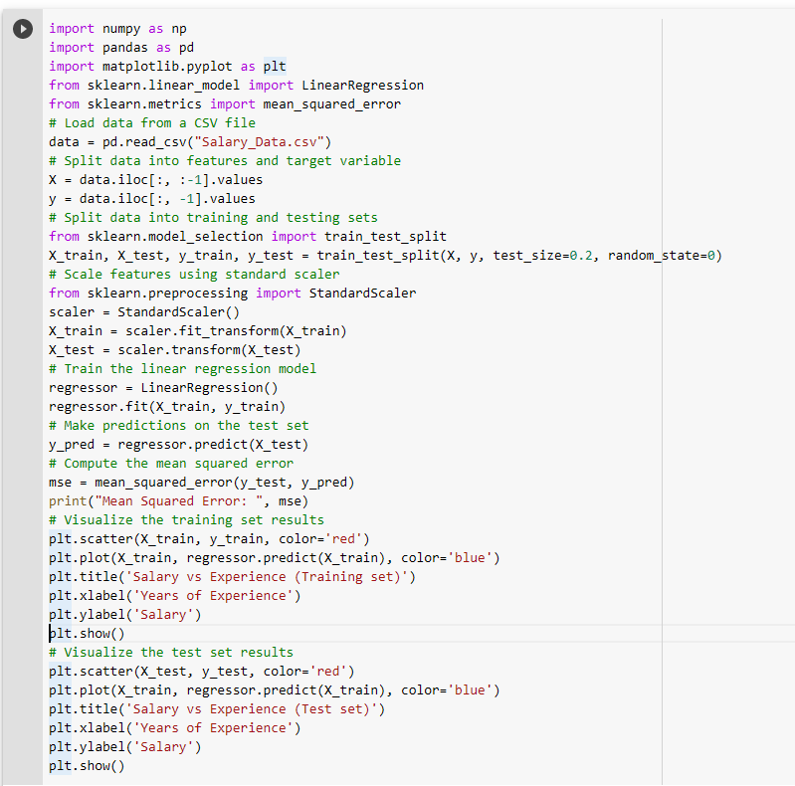

Code :

import numpy as np

import pandas as pd

import matplotlib.pyplot as plt

from sklearn.linear_model import LinearRegression

from sklearn.metrics import mean_squared_error

# Load data from a CSV file

data = pd.read_csv("Salary_Data.csv")

# Split data into features and target variable

X = data.iloc[:, :-1].values

y = data.iloc[:, -1].values

# Split data into training and testing sets

from sklearn.model_selection import train_test_split

X_train, X_test, y_train, y_test = train_test_split(X, y, test_size=0.2, random_state=0)

# Scale features using standard scaler

from sklearn.preprocessing import StandardScaler

scaler = StandardScaler()

X_train = scaler.fit_transform(X_train)

X_test = scaler.transform(X_test)

# Train the linear regression model

regressor = LinearRegression()

regressor.fit(X_train, y_train)

# Make predictions on the test set

y_pred = regressor.predict(X_test)

# Compute the mean squared error

mse = mean_squared_error(y_test, y_pred)

print("Mean Squared Error: ", mse)

# Visualize the training set results

plt.scatter(X_train, y_train, color='red')

plt.plot(X_train, regressor.predict(X_train), color='blue')

plt.title('Salary vs Experience (Training set)')

plt.xlabel('Years of Experience')

plt.ylabel('Salary')

plt.show()

# Visualize the test set results

plt.scatter(X_test, y_test, color='red')

plt.plot(X_train, regressor.predict(X_train), color='blue')

plt.title('Salary vs Experience (Test set)')

plt.xlabel('Years of Experience')

plt.ylabel('Salary')

plt.show()

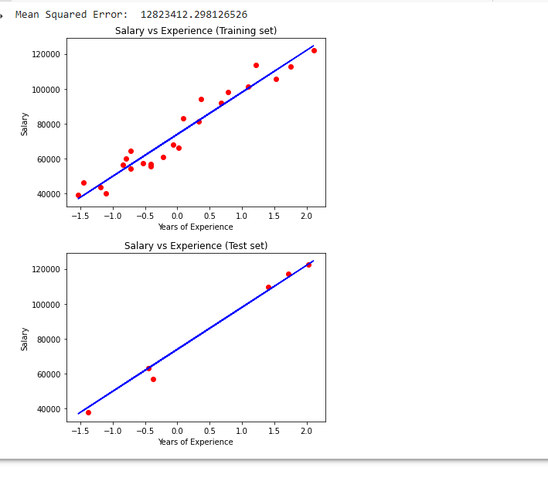

Data set :

[Salary_Data.csv | Kaggle](https://www.kaggle.com/datasets/devchauhan1/salary-datacsv)

